Compound Root

What is Compound Root
# Source: AI Source: Provided by: [Data Path: Persons Table -> ID Column: 1, Name_En Column: Motasem Essam] -> From: [Chatgpt (GPT-4-turbo)] on [7/29/2025]
A compound root is a root formed by combining two or more root morphemes—each carrying meaning—into a single base unit that functions as the core of a word. This type of root usually appears in compound words, especially in classical or scientific vocabulary.

🔹 Definition of Compound Root:
# Source: AI Source: Provided by: [Data Path: Persons Table -> ID Column: 1, Name_En Column: Motasem Essam] -> From: [Chatgpt (GPT-4-turbo)] on [7/29/2025]
A compound root is made up of two or more bound or free roots that are joined together to create a new root from which words can be derived.

🔹 Examples of Compound Roots:
# Source: AI Source: Provided by: [Data Path: Persons Table -> ID Column: 1, Name_En Column: Motasem Essam] -> From: [Chatgpt (GPT-4-turbo)] on [7/29/2025]
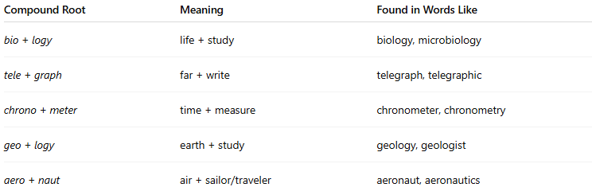
Compound Root | Meaning | Found in Words Like
bio + logy | life + study | biology, microbiology
tele + graph | far + write | telegraph, telegraphic
chrono + meter | time + measure | chronometer, chronometry
geo + logy | earth + study | geology, geologist
aero + naut | air + sailor/traveler | aeronaut, aeronautics
These examples are based on Greek and Latin roots that are commonly used in academic and scientific vocabulary.

🔹 Features of Compound Roots:
# Source: AI Source: Provided by: [Data Path: Persons Table -> ID Column: 1, Name_En Column: Motasem Essam] -> From: [Chatgpt (GPT-4-turbo)] on [7/29/2025]
- ✅ Consist of two or more root morphemes.
- ✅ Often appear in technical, scientific, or classical vocabulary.
- ✅ Can be formed from free or bound roots (often from Latin/Greek).
- ✅ Each part contributes to the overall meaning.
- ❌ Cannot always stand alone; many are bound forms in modern usage.

🔹 Compound Root vs. Compound Word:
# Source: AI Source: Provided by: [Data Path: Persons Table -> ID Column: 1, Name_En Column: Motasem Essam] -> From: [Chatgpt (GPT-4-turbo)] on [7/29/2025]
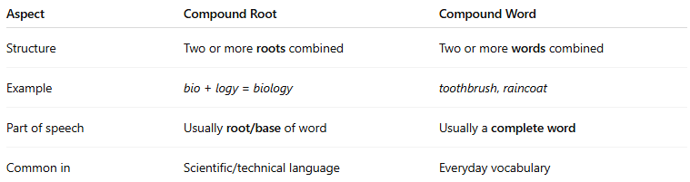
Aspect | Compound Root | Compound Word
Structure | Two or more roots combined | Two or more words combined
Example | bio + logy = biology | toothbrush, raincoat
Part of speech | Usually root/base of word | Usually a complete word
Common in | Scientific/technical language | Everyday vocabulary

🔹 Types of Roots Recap (Comparison):
# Source: AI Source: Provided by: [Data Path: Persons Table -> ID Column: 1, Name_En Column: Motasem Essam] -> From: [Chatgpt (GPT-4-turbo)] on [7/29/2025]
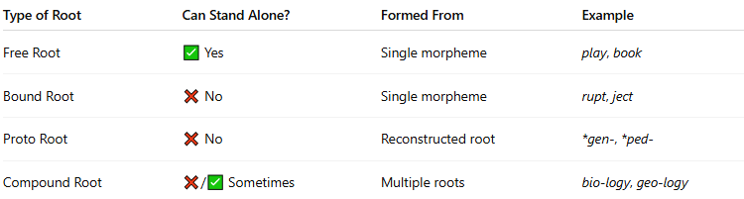
Type of Root | Can Stand Alone? | Formed From | Example
Free Root | ✅ Yes | Single morpheme | play, book
Bound Root | ❌ No | Single morpheme | rupt, ject
Proto Root | ❌ No | Reconstructed root | *gen-, *ped-
Compound Root | ❌/✅ Sometimes | Multiple roots | bio-logy, geo-logy

